**Steps to reproduce the issue:**

**On the Server machine:**Create a User in AD (Active Directory) of “Windows Server 2016” using VM Ware.

**On the Client machine:**  
Add the domain to the client machine in Windows 10 machine installed on VM Ware.  
Build the code in Visual Studio 2019 in both Debug and Release mode.  
Copy the “SampleV2CredentialProvider.dll “ and paste it in “C:\Windows\System32” folder of Windows 10 system.  
And run the Register.reg files to register the component in Windows 10 system, which comes with the source code, in Windows 10 desktop on VMware.  
Now the dll “SampleV2CredentialProvider.dll” is registered and the Credential Provider i.e., CP is installed, using an administrator account.  
Log out of Administrator account from the system.

You will see the screen:

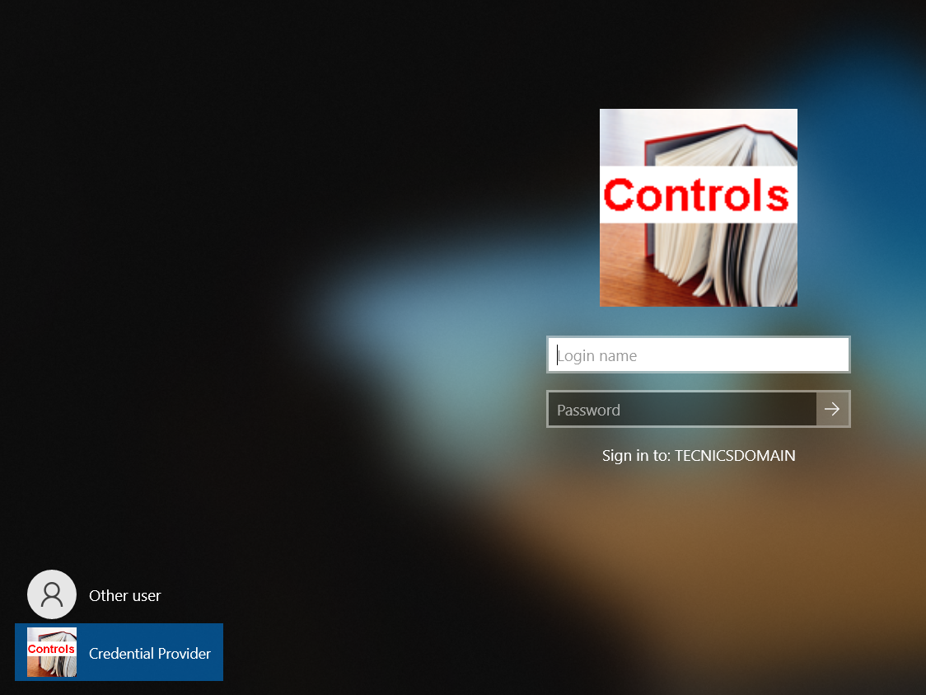

Select the Credential Provider as shown in the figure.

Enter the “Username” and “Password” for the account created in AD in Windows 10 Server system and press the button 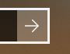

You will get successfully logon into the system.

**Note:  
Open the Registry with “Registry Editor” call “Run”.**

**In the following path: HKEY_LOCAL_MACHINE\SOFTWARE\Microsoft\Windows\CurrentVersion\Policies\System**

**Right click in “System” space and create a DWORD called “dontdisplaylastusername” variable and assign it 1.**

The Reason for creating is to make sure the **“Credential Provider”** catches the **CPUS_UNLOCK_WORKSTATION**. Otherwise it will catch only the **CPUS_LOGON** event only.  
 **On the Server machine:**In the Windows Server 2016 machine’s “Server Manager application” click on “Tools” menu.  
Select the “Active Directory Users and Computers”.   
In the window of “Active Directory Users and Computers” select the “Users” folder under the Domain Branch, in the displayed tree of “Active Directory Users and Computers”.  
In the Displayed Users list, select the user you have created, by double clicking it.  
Select the Account Tab.  
Under the “Account options”: Select the checkbox for “User must change password at next logon”.  
Under the “Account expires:”: Select the radio button for “End of: “ and select the date of account expires.  
Push the button Apply and push the button OK.

Again on the “Server Manager” window displayed, clicked the refresh Button.



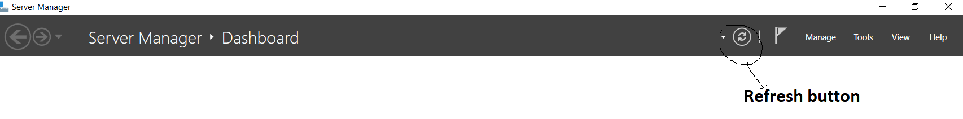

On the Client machine:  
Lock the system, by selecting the “Lock” menu.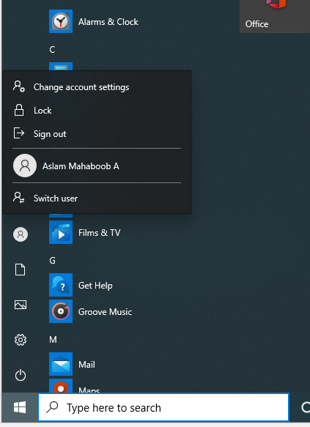  
  
You will see the following screen: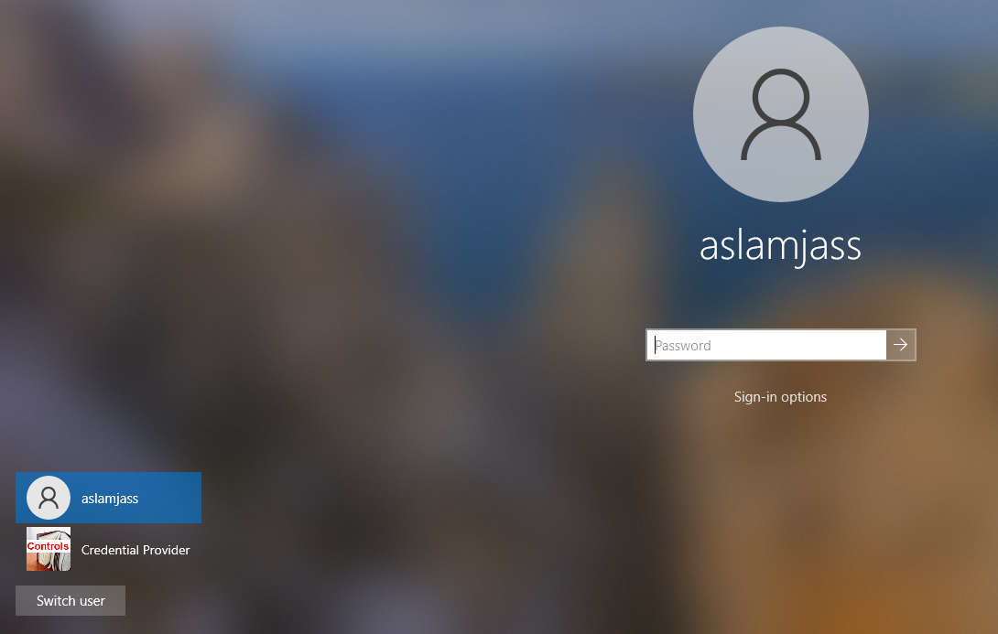

Click on the Sign-in Options You will see the following screen:

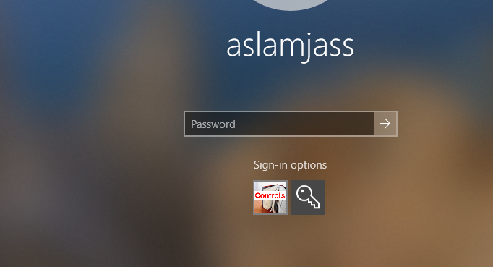

Select the controls image icon button and type the password in the password filed.

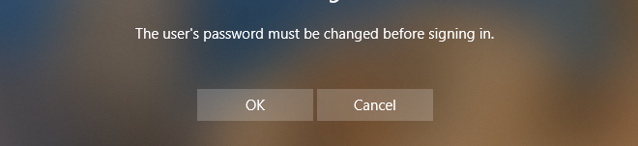

Press the button OK you will see the following screen, below which does not have the OldPassword, NewPassword and ConfirmPassword on the seen.  
  
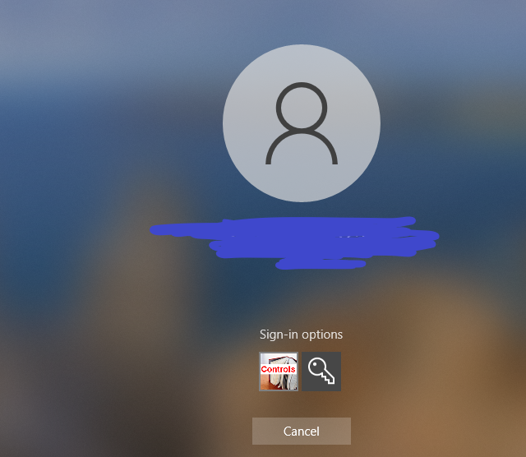

Restart the system with admin login credentials you will see the logs in the log file in **“c:\\SampleCredentialProvider.log”.**

You will see that the following components “Old Password, New Password and Confirm Password”, failed to load on the tile of CP in the logs under CPUS _UNLOCK_WORKSTATION.

Logs showing the failure of the components.

20210719 1543470972: Added CSampleCredential::SetSelected()

20210719 1543470987: CSampleCredential:: SetSelected() _cpus == CPUS_CHANGE_PASSWORD

20210719 1543470987: CSampleCredential:: SetSelected() SUCCEEDED SFI_USERNAMELABLE: 183

20210719 1543470987: CSampleCredential:: SetSelected() SUCCEEDED SFI_USERNAMELABLE: 183

20210719 1543470987: CSampleCredential:: SetSelected() SUCCEEDED SFI_LOGIN_NAME: 183

20210719 1543470987: CSampleCredential:: SetSelected() SUCCEEDED SFI_LOGIN_NAME: 183

20210719 1543470987: CSampleCredential:: SetSelected() SUCCEEDED SFI_PASSWORD: 183

20210719 1543470987: CSampleCredential:: SetSelected() FAILED SFI_OLDPASSWORD_TEXT: 183

20210719 1543470987: CSampleCredential:: SetSelected() FAILED SFI_OLDPASSWORD: 183

20210719 1543470987: CSampleCredential:: SetSelected() FAILED SHStrDupW(m_pssword, &_rgFieldStrings[SFI_PASSWORD]): 183

20210719 1543470987: CSampleCredential:: SetSelected() FAILED SFI_OLDPASSWORD: 183

20210719 1543470987: CSampleCredential:: SetSelected() FAILED SFI_NEWPASSWORD_TEXT: 183

20210719 1543470987: CSampleCredential:: SetSelected() FAILED SFI_NEWPASSWORD: 183

20210719 1543470987: CSampleCredential:: SetSelected() FAILED SFI_CONFPASSWORD_TEXT: 183

20210719 1543470987: CSampleCredential:: SetSelected() FAILED SFI_CONFPASSWORD: 183

20210719 1543470987: CSampleCredential:: SetSelected() SUCCEEDED SFI_SUBMIT_BUTTON: 183

20210719 1543470987: CSampleCredential:: SetSelected() FAILED SFI_SUBMIT_BUTTON: 183